**CIRCAC/James Carter Memorial**

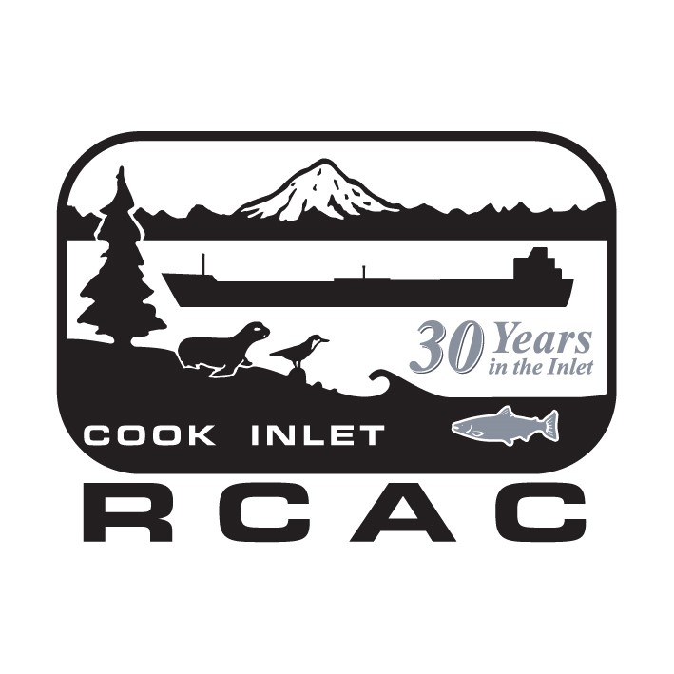

**Scholarship for Environmental Sciences**

**2022 Application**

**Cook Inlet Regional Citizens Advisory Council**

***~ PLEASE READ THE ATTACHED GUIDELINES CAREFULLY BEFORE SUBMITTING YOUR APPLICATION ~***

**~ *ALL INFORMATION WILL BE KEPT CONFIDENTIAL* ~**

FULL NAME: ______________________________________________________________________ PHONE: ____________________________________

ADDRESS: _____________________________________________________________________ E-MAIL: ________________________________________

NAME(S) OF PARENTS/GUARDIANS: _________________________________________________________________________________________

DATE OF BIRTH: ____________ PLACE OF BIRTH: ______________________________ # YEARS IN COOK INLET AREA: ______

HIGH SCHOOL: ________________________________________________ GPA: _________________ GRAD. DATE: __________________

UNIVERSITY, COMMUNITY COLLEGE OR VOCATIONAL SCHOOL YOU ATTEND/PLAN TO ATTEND: __________________

____________________________________________________________________________________________________________________________________

EDUCATIONAL / VOCATIONAL GOALS: ______________________________________________________________________________________

____________________________________________________________________________________________________________________________________

____________________________________________________________________________________________________________________________________

SCHOOL-RELATED ACTIVITIES, HONORS & AWARDS (w/dates): _________________________________________________________

____________________________________________________________________________________________________________________________________

____________________________________________________________________________________________________________________________________

CIVIC HONORS (w/dates): _____________________________________________________________________________________________________

____________________________________________________________________________________________________________________________________

VOLUNTEER OR WORK ACTIVITIES (w/dates): _____________________________________________________________________________

____________________________________________________________________________________________________________________________________

____________________________________________________________________________________________________________________________________

Please attach additional materials and pages for further explanation as necessary.

*I attest that the information contained in this application package is true.*

SIGNATURE OF APPLICANT: __________________________________________________ DATE: ________________________________________

***~ LATE, INCOMPLETE OR UNRELATED APPLICATIONS WILL NOT BE CONSIDERED ~***

**DEADLINE: Completed applications must be received at CIRCAC by mail or email by 5:00 pm, Wednesday, MARCH 23, 2022. 8195 Kenai Spur Highway, Kenai, AK 99611, or** [***jerryrombach@circac.org***](mailto:jerryrombach@circac.org)

**CALL (907) 398-6210 if questions or for more information.**

**Cook Inlet Regional Citizens Advisory Council**

**Program Guidelines - 2022 James Carter Scholarship for Environmental Sciences**

**$2,500.00 Scholarship Available**

**Background:** Congress created the Cook Inlet Regional Citizens Advisory Council (CIRCAC) via the Oil Pollution Act of 1990 (OPA 90). The Council is mandated to perform environmental monitoring in Cook Inlet, Alaska; engage in oil spill prevention and response planning; and educate the citizens of Cook Inlet with information about our work. In that spirit, we are pleased to offer a $2,500 scholarship for a selected student with educational and career ambitions that mirror our Congressional mandates. CIRCAC’s goal is to assist Cook Inlet area students to launch or complete an undergraduate degree program in environmental sciences in any of a broad range of applicable areas related to ocean studies.

**~ Please read and follow these Guidelines carefully; omissions may disqualify applicants ~**

**Eligibility:** Graduating seniors and recent graduates who are planning to attend a college or university to pursue an undergraduate degree in an environmental science – **and who reside in the vicinity of Cook Inlet, Alaska** (specifically: Anchorage, the Kenai Peninsula [excluding Seward], Kodiak Island) **–** are eligible to apply. Seniors must be attending schools in the Anchorage School District, Kenai Peninsula Borough School District, Kodiak Island Borough School District, a home schooling program, or private schools within the boundaries of these districts, or be a recent high school graduate. Recently discharged veterans are also encouraged to apply. Past applicants may re-apply.

**Submission:** A completed application package must be submitted and received by the deadline indicated on the application, and must be accompanied by:

* Completed and signed Application Form
* Most recent transcript (copy acceptable)
* Letters of recommendation (at least 2; not from family members)
* Personal essay (500 words or less) outlining: your educational and career goals (particularly as they align with CIRCAC’s objectives); a statement of financial benefit; personal accomplishments; and how this scholarship will help you impact the culture and environment of Cook Inlet
* Proof of Alaska residency (copies of PFD eligibility; driver’s license; military ID; other)

**Process:** Late or incomplete applications at deadline will be rejected. Materials will be reviewed for completeness and eligibility. A committee of CIRCAC Directors will select the finalists for interviews, which will last about 15 minutes and be conducted via teleconference, typically on a single day. Recipients will be selected that day. All applicants will be notified following the Committee’s selection.

Scholarship Awards will be announced to the community through notices to local media outlets, and through CIRCAC public outreach efforts (newsletter, website, others)

Scholarships are presented in the form of a “Letter of Award” and Certificate issued by CIRCAC to the recipient. Funds will be released in a single payment directly to the school or program upon receipt of verification of enrollment (e.g. - course schedule and Student ID) issued by the school’s proper authority. Scholarship funds may not be used to cover payments for any prior academic period. Scholarships are intended for the upcoming academic year only, without permission from CIRCAC.

***~ Completed Applications Must be Received by 5:00 p.m. March 23, 2022 ~***

**Send Applications and related materials by mail or email to:**

CIRCAC Scholarship Committee – 8195 Kenai Spur Highway, Kenai, AK 99611 or

[jerryrombach@circac.org](mailto:jerryrombach@circac.org) ~ Questions? Call: (907) 398-6210